# Jeopardy README

Thanks for downloading my project! I built it using a couple of weekends of my own time, and my friends and I have gotten a solid amount of enjoyment out of it, and I hope you enjoy it too. This build allows you to pretty closely emulate a game of Jeopardy at home. The game plays in a web browser (Google Chrome recommended), but no internet connection is required.

You’ll need:

* The contents of this zip file
* A computer (preferably a laptop with a second monitor, or a way to dual-screen to a TV)
* A TV or a second monitor (as mentioned above) with the ability to hook into your computer (I use an HDMI cable)
* A buzzer system (optional, you can build your buzzer system with the instructions here: <http://imgur.com/a/riJsr>). Alternatively, you can use your keyboard as the buzzers. Left arrow is player 1’s buzzer, up arrow is player 2’s buzzer, and right arrow is player 3’s buzzer. The host controls the game with the down arrow. In this case, it may be best to hook up a USB keyboard to the computer, so the host and players can sit somewhat separately.
* You and up to 3 friends

## What’s in the box

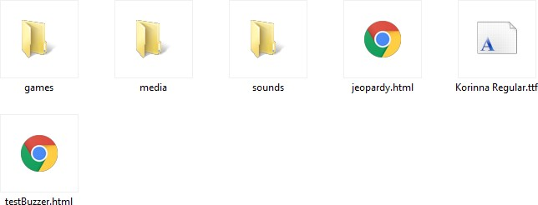

* Games – a series of text files (I created the .jpd file extension to be fancy, but really, they’re text files) containing game information. Within this folder, there are two more folders:
  + Full games – any full games I could pull from the j-archive website. These are games which were fully played (i.e. all clues were revealed) and had no video or audio clues (can’t really save all of those into this folder, anyway).
  + Mix – games composed to a mix of categories from multiple real games. Fully-played

categories from games that weren’t fully played are stitched together into full games in these files.

You can create your own games by opening a game file and seeing the format. They’re just text files, so it’s quite simple.

* Media/Sounds – don’t mess with these folders. Alright, fine…you can…but I’m not responsible if you do. They contain the sound and picture files necessary for the game. The media folder just contains the daily double graphic, but in future updates, I might add more stuff if warranted.
* 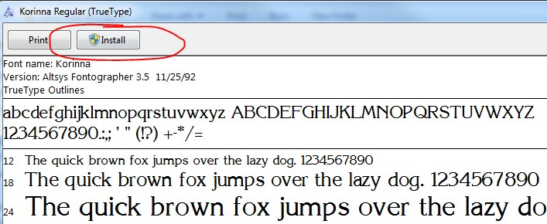Korinna TTF – THIS IS THE FONT IN WHICH THE JEOPARDY CLUES ARE DISPLAYED. You should be able to just open this file and click “Install,” and it should install the font on your system:

Now for the good stuff. Hook up your computer to your TV or second monitor, however you do it. Verify that your desktop is extended across the two screens. If you’ve downloaded this game, you probably

know how to this, and if not, just google it. When that’s done, the “host” should move his or her screen so that the players cannot see it, and the players should sit in a place where they can see the TV (or second monitor) but not the host’s screen.

## Playing the Game

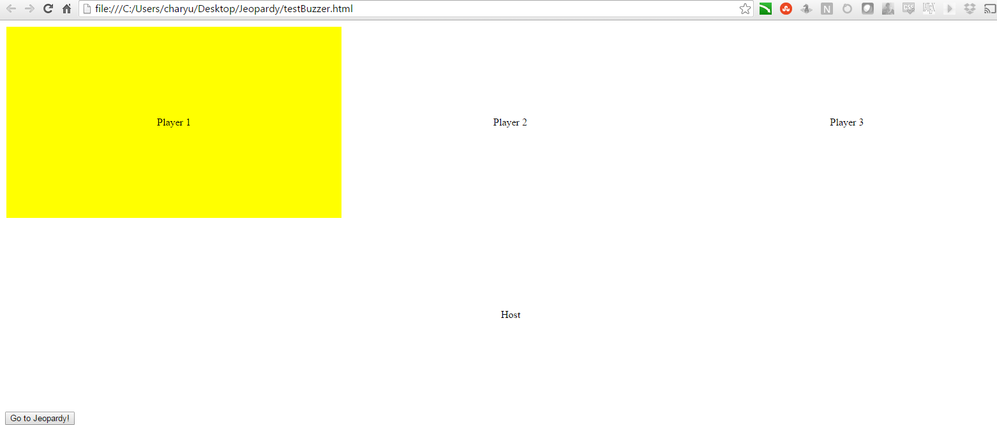You can jump right in and open up jeopardy.html (Google Chrome recommended) if you wish. However, I also included testBuzzer.html so that you can (what else?) test your buzzers. Open that file, and have each player (and the host) press their buzzer. The corresponding cell on the page should light up.

**DISABLE YOUR POP UP BLOCKER!**

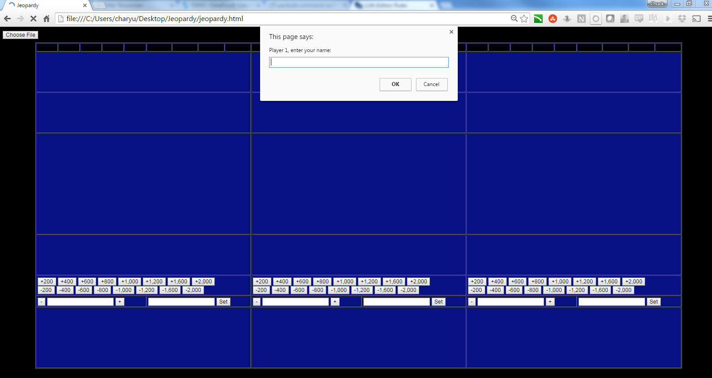When you’re ready, click the “Go to Jeopardy!” button at the bottom. You should be taken to the game.

Enter your player names as prompted. If you are playing with only one or two players, enter a space as the name for the non-existent player. You must enter at least one non-blank name.

Choosing a game file

After entering player names, you should be taken to a screen with a button that says “Choose File.” Click it and navigate to the where you saved this file, and select the “games” folder.

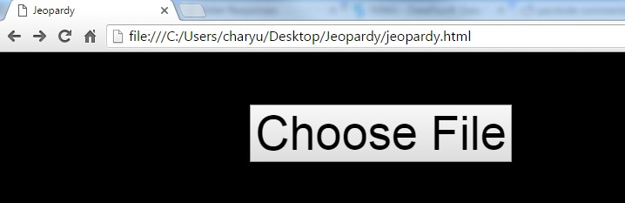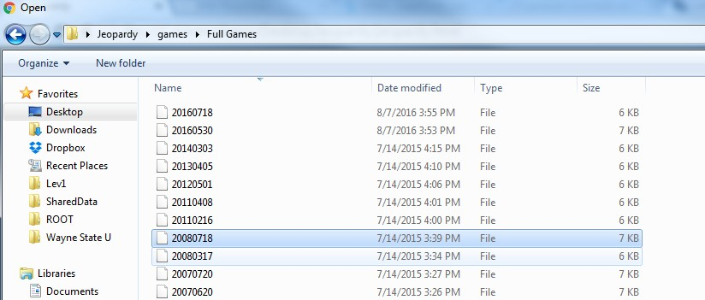

Double click on a game, or select a game and click “open.”

A new window should pop up, mostly blank, except for a “Show key” button. This displays the answer key. Move the key window to the host’s screen, and click the button. You should be able to see the first round’s key.

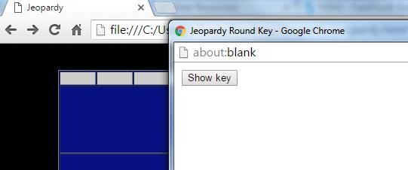

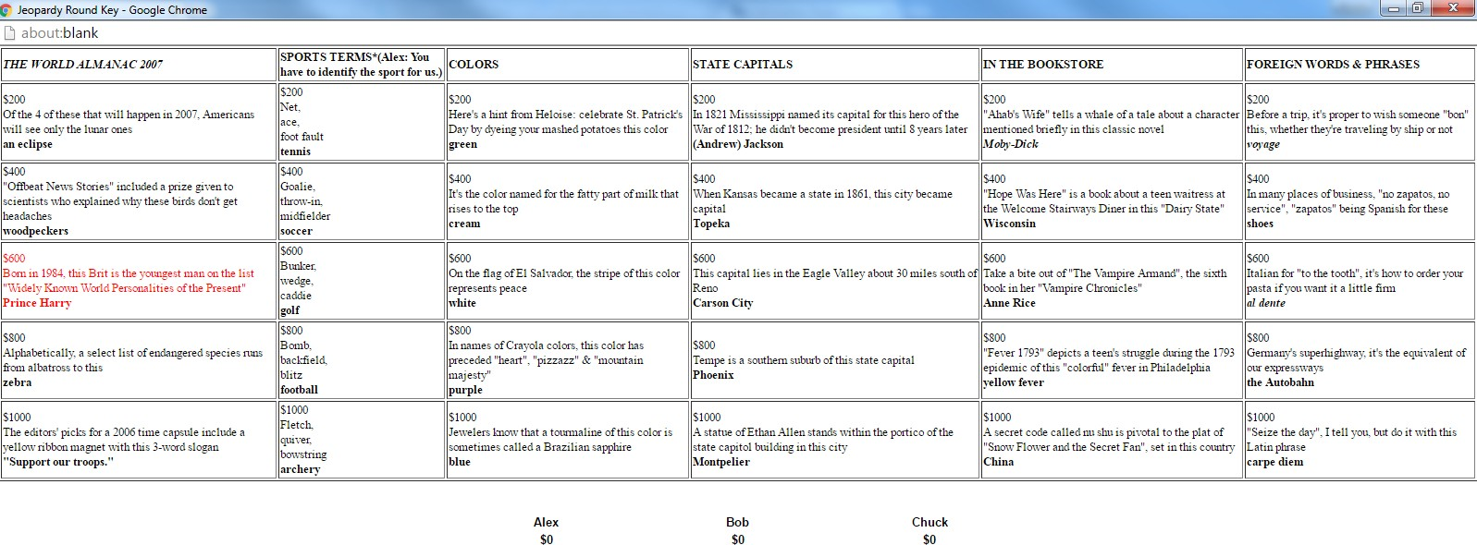

Each category is listed at the top (along with anything that Alex said about it, which the host should relay to the players). The clues are listed below the categories, and the correct responses are in bold. The daily double is in red. Again, the players should never see this screen – only the host should be able to see it. If the key does not pop up, be sure that your popup blocker is disabled.

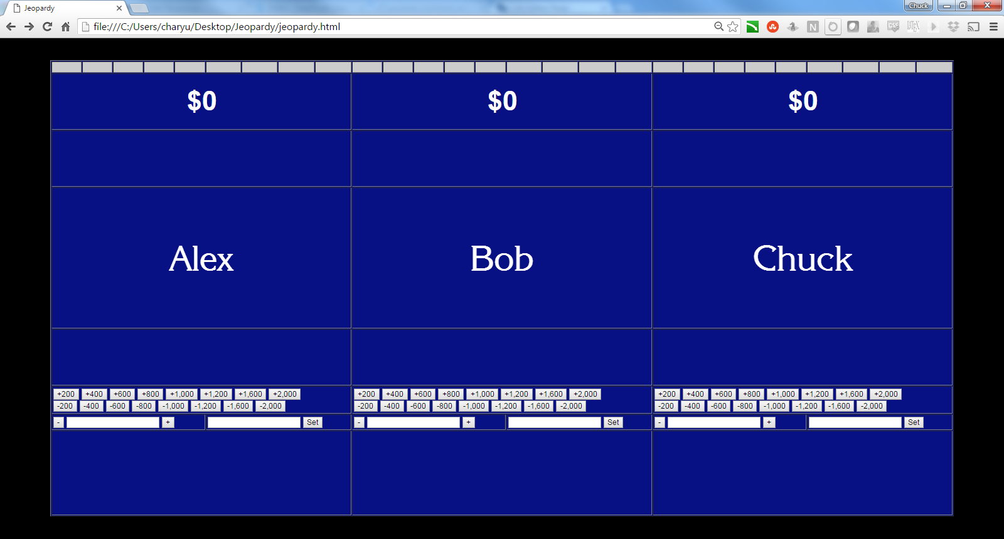Moving back to the player screen, the lecterns should come into view, with the player names.

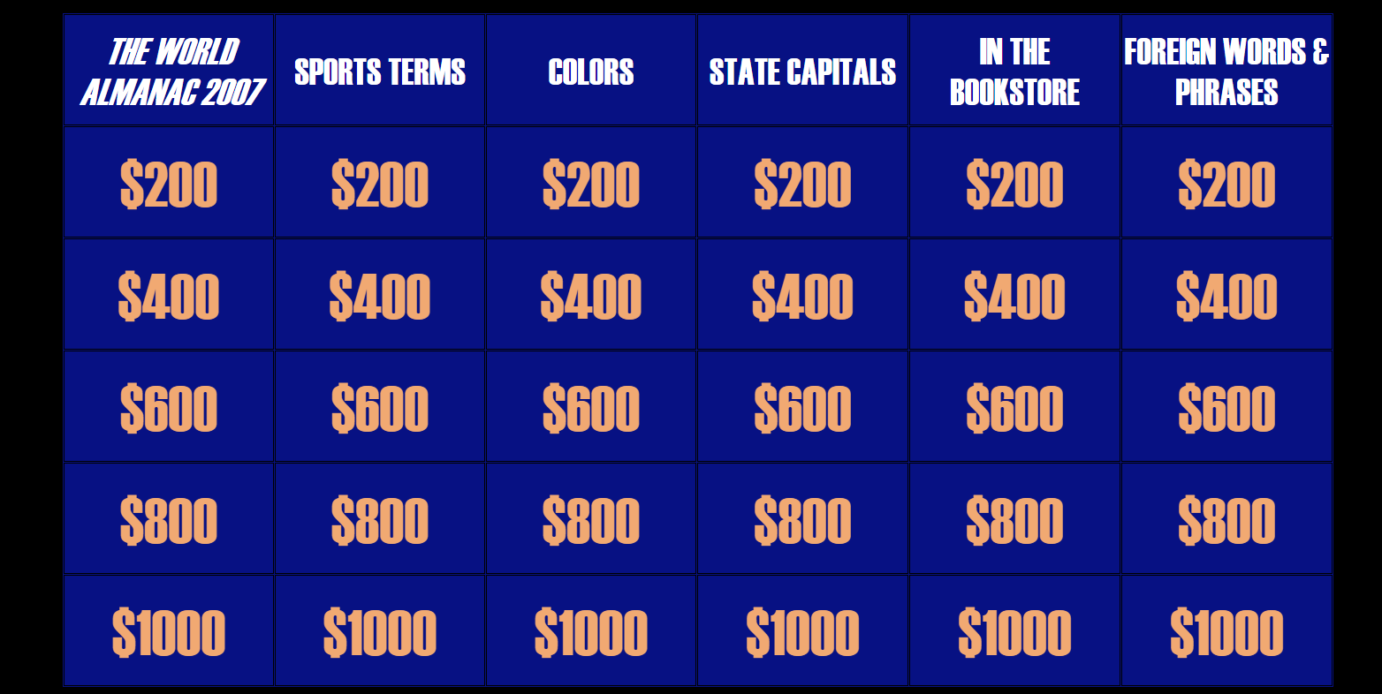When ready, the host presses his button, and the game board comes into view.

In general, the host button is used to advance screens during the game. On most screens that don’t automatically advance, the host button will advance the screen.

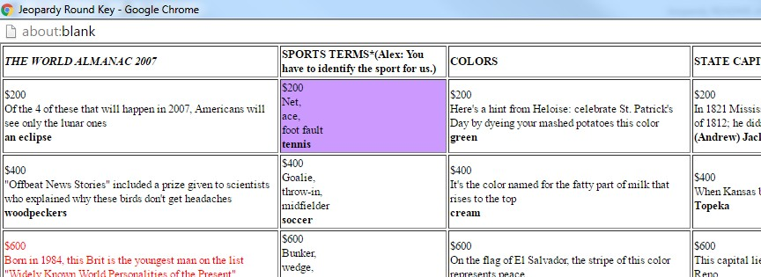Click on a clue to select it. As you mouse-over the clues, note that the host’s answer key highlights the clue that is being hovered over. This way, the host can keep his or her eyes on his own screen and does not have to continuously look back and forth. **If the host key is accidentally closed for any reason, the host may reopen it at any time by pressing “K.”**

### You must click the clue on the main game window, not on the host key.

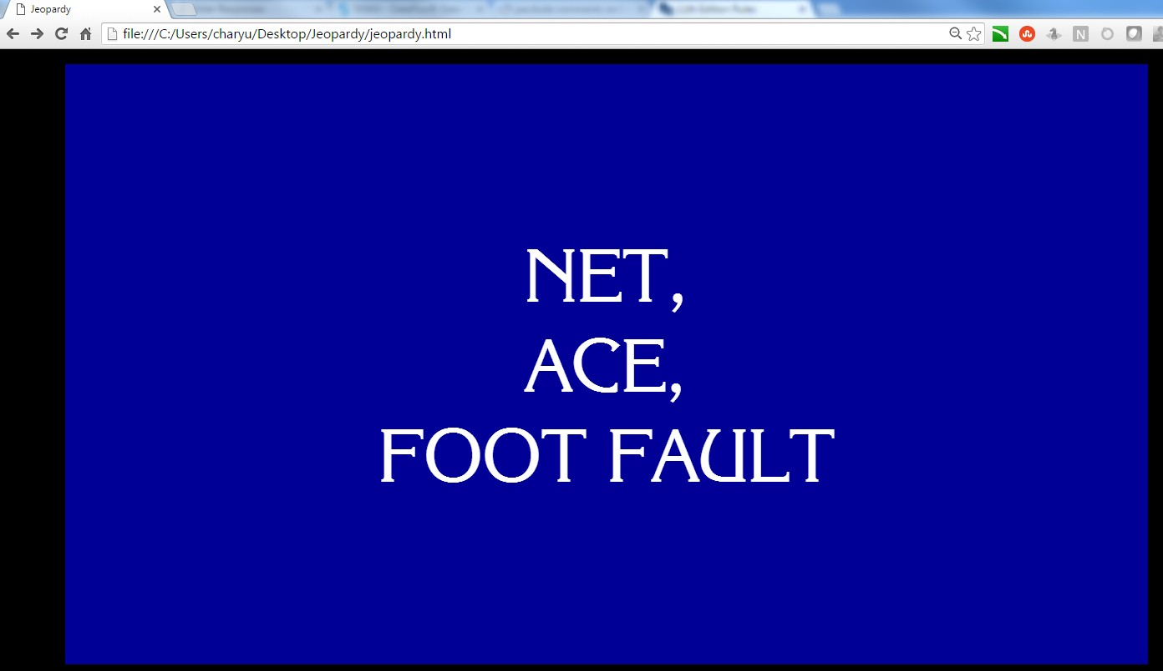The value of the clue will briefly flash on the main screen, and the clue will display. The host should read the clue and then **push the host button. No one can buzz in until the host button is pressed, signifying that “Alex Trebek” is done reading the clue.**

When the host key is pressed, the lecterns come back into view, and players may buzz in. Again, if you do not have the buzzer system, use the left, up, and right arrows, respectively, for player 1, 2, and 3 to buzz in.

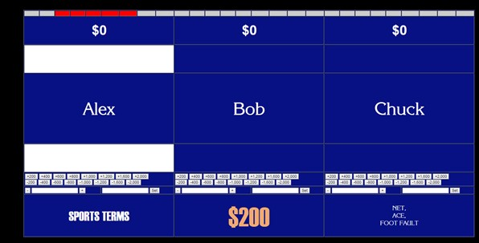

If a player buzzes, in, their lectern lights up. If they buzz in before the host presses the button to activate the buzzers, then they are locked out for 1/3 of a second (editable in the source code, if you wish).

The host should call on the player. If the player is correct, the host presses “C” to indicate a correct

response. Otherwise, the host should press “X” to indicate an incorrect response. Scores are adjusted accordingly. If the host makes any mistakes in scoring, the row of buttons and entry fields underneath the lecterns can adjust the scores manually. There are buttons to add or subtract any multiple of $200 up to $2000 at once. The left text entry field under each player is used to manually add or subtract any number of dollars, and the right text entry field under each player is used to manually set the score to a specific dollar amount.

If a correct response is given (and the host presses “C” to acknowledge it), the game will automatically advance back to the game board.

Note that on the key, clues that have been selected are highlighted in gray.

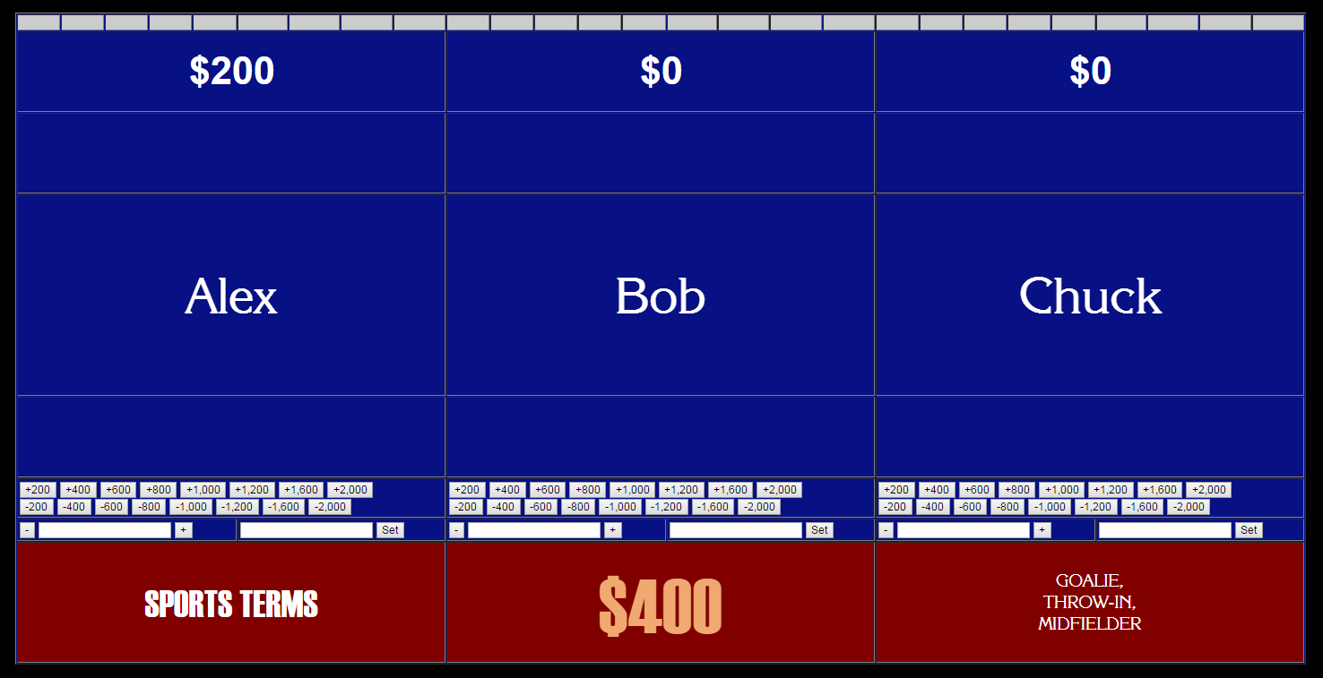The default buzzer timeout is 4 seconds on a regular clue (and 10 seconds on a daily double). Both of these are easily editable in the source code. If no one buzzes in within the time limit, the timeout sound should play and the bottom row of the lecterns, with the category, value, and clue reminders, will turn red.

The host presses his button to advance to the game board.

When a daily double is found, the graphic should flash on the screen, followed by the category:

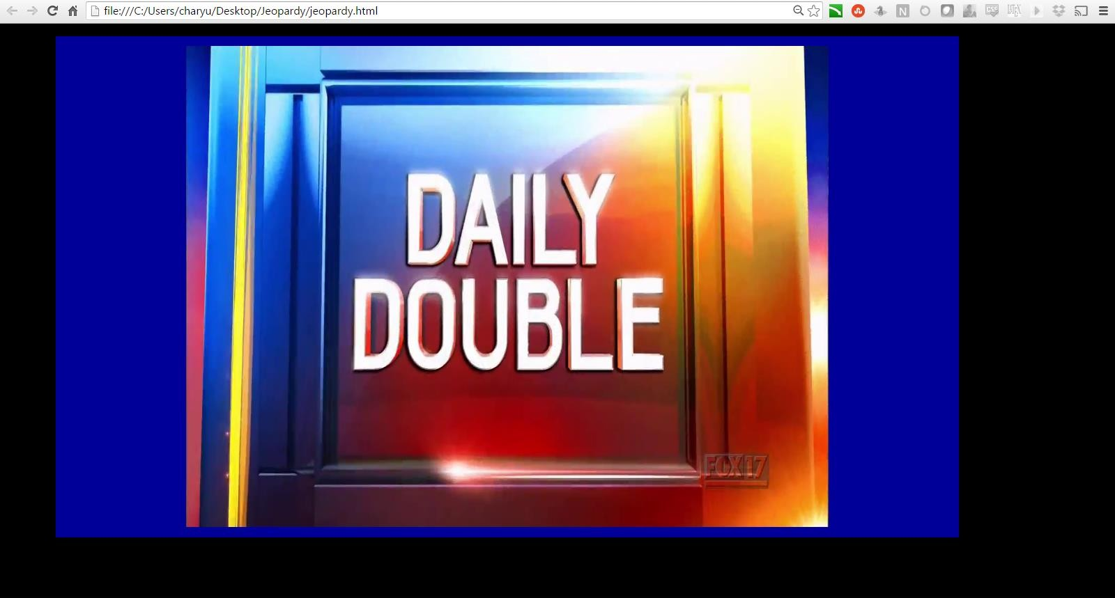



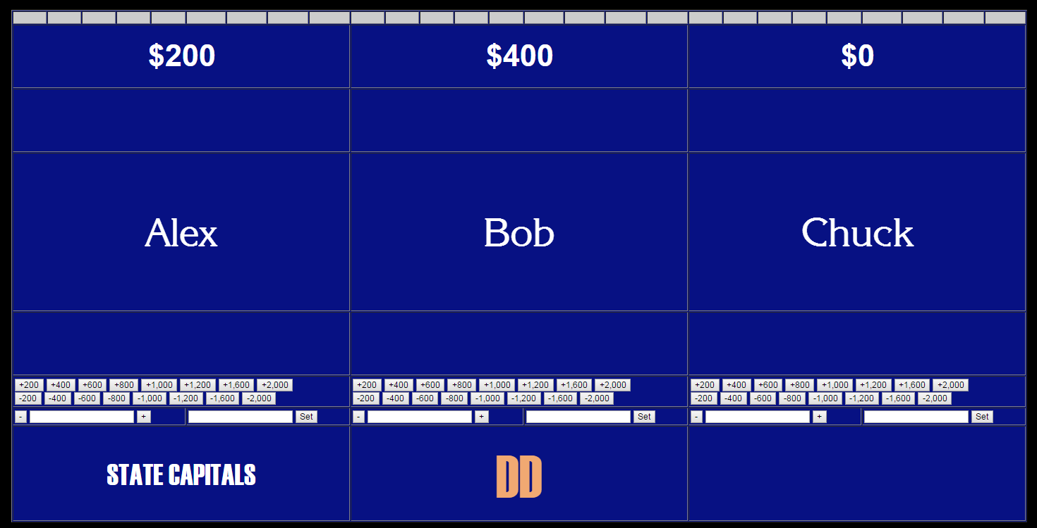Push the host button to advance. The lecterns display, with a reminder for the category, and the player who selected the clue verbally makes a wager. Remember that the official rules of Jeopardy say that the minimum wager is $5, and the maximum wager is the larger of the player’s current score, or $1000 in round one and $2000 in round 2.

When the player has made a wager, press the host button again. Read the clue and press the host button to start the timer. The screen will not change.

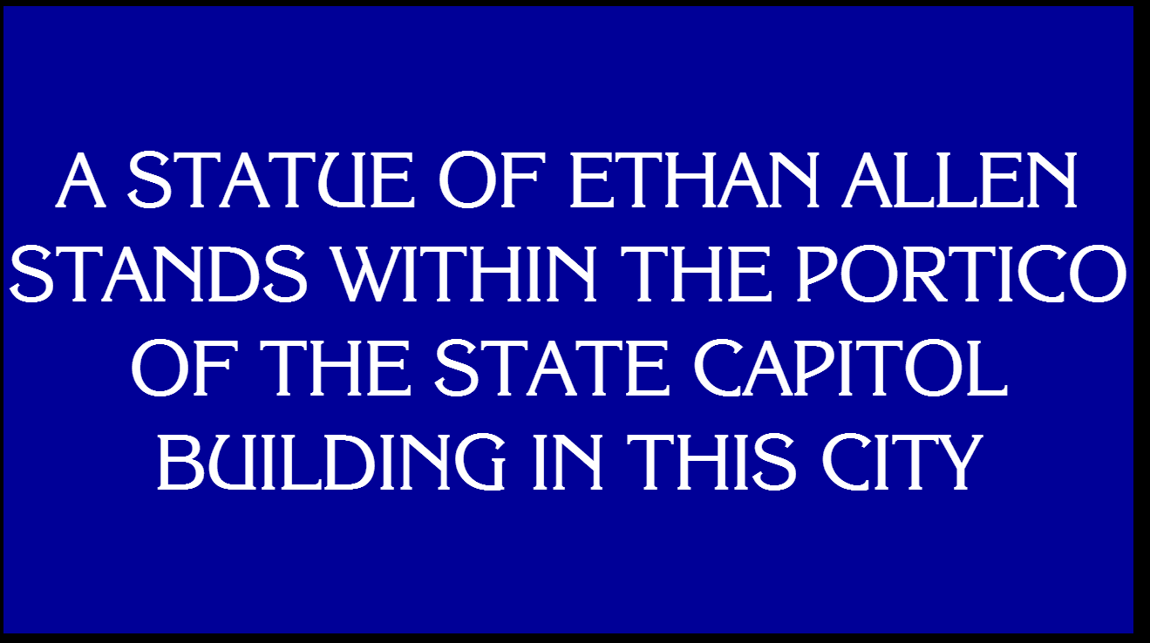

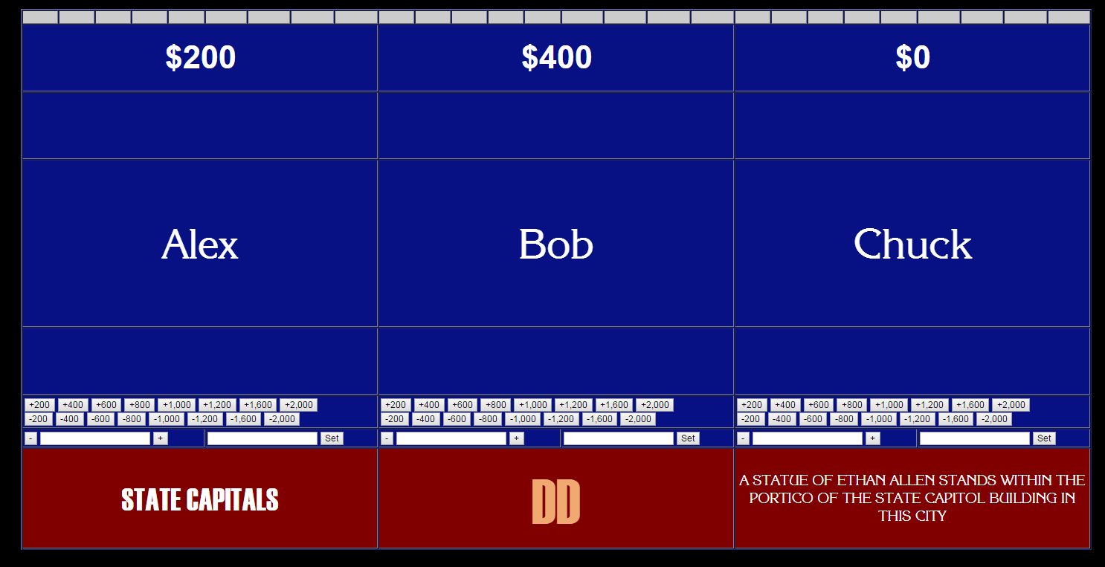When time runs out, or when the host button is pressed again, the lecterns will display. Manually adjust the player’s score. There is no automatic way to do this as of now, as the game does not know who selected each clue, so it does not know who selected the daily double.

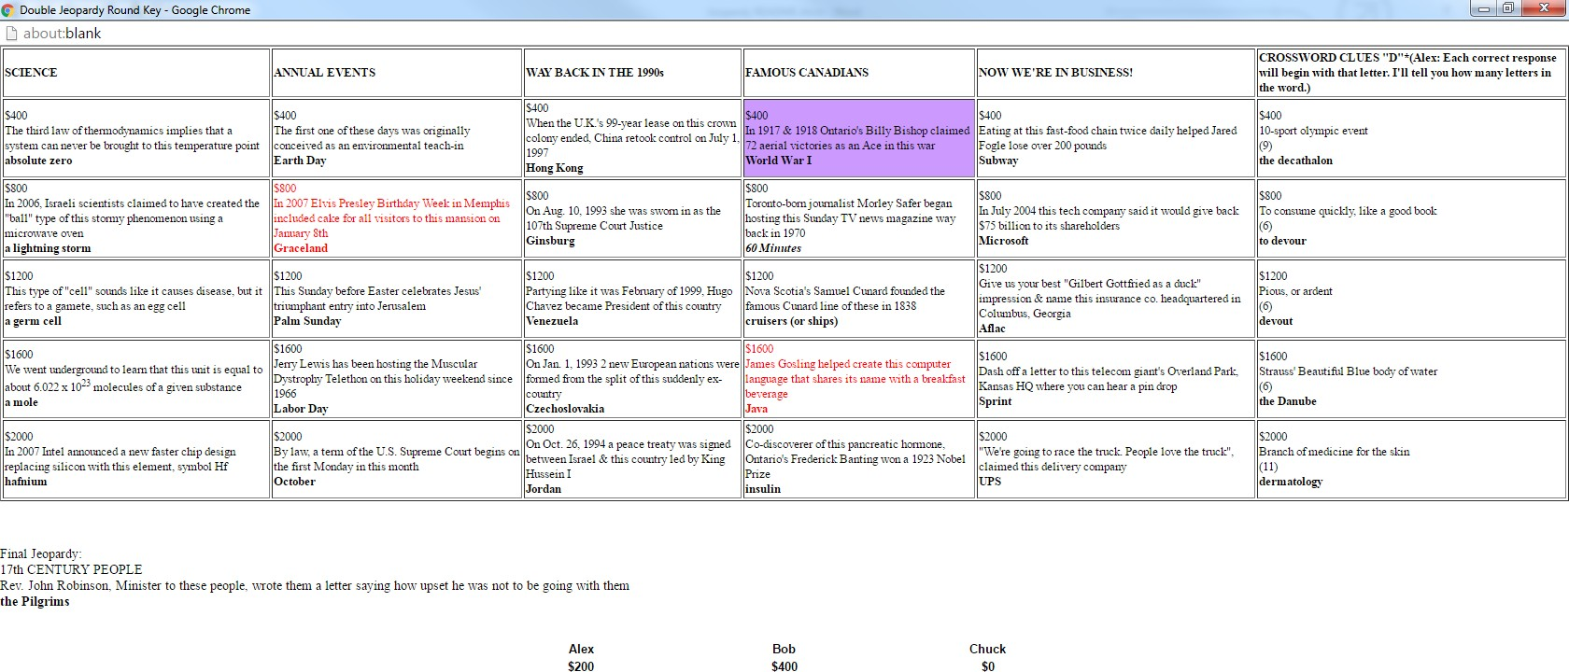When round one ends, a message will display, indicating the player who selects first in Double Jeopardy. Acknowledge it, and a new key will appear for Double Jeopardy. Move it over to the host window, as you did with the first key, and click “show key.”

Note that there are now two daily doubles, and the Final Jeopardy information is also at the bottom. When Final Jeopardy comes up, an alert will pop up.

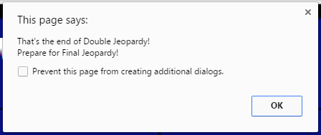

Acknowledge it and the Final Jeopardy category will display on the screen. Press the host button to advance.

The lecterns should reappear with a category reminder. Each player secretly writes down a wager, between 0 and their current score, inclusive. Players who do not have positive score are eliminated before Final Jeopardy.

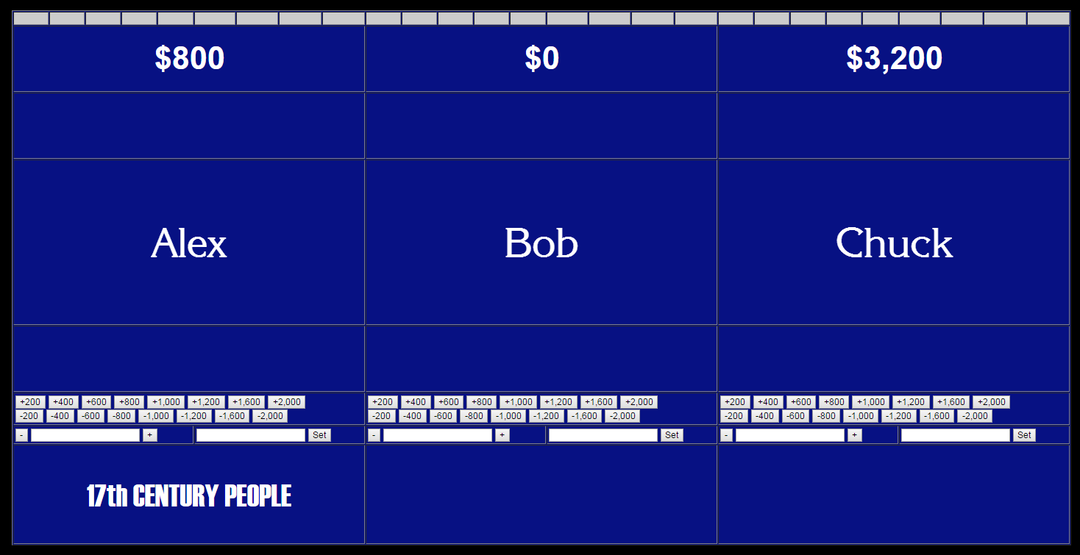

The clue is displayed. The host reads the clue, and then presses the host button to start the 30-second timer. Players write their responses down.

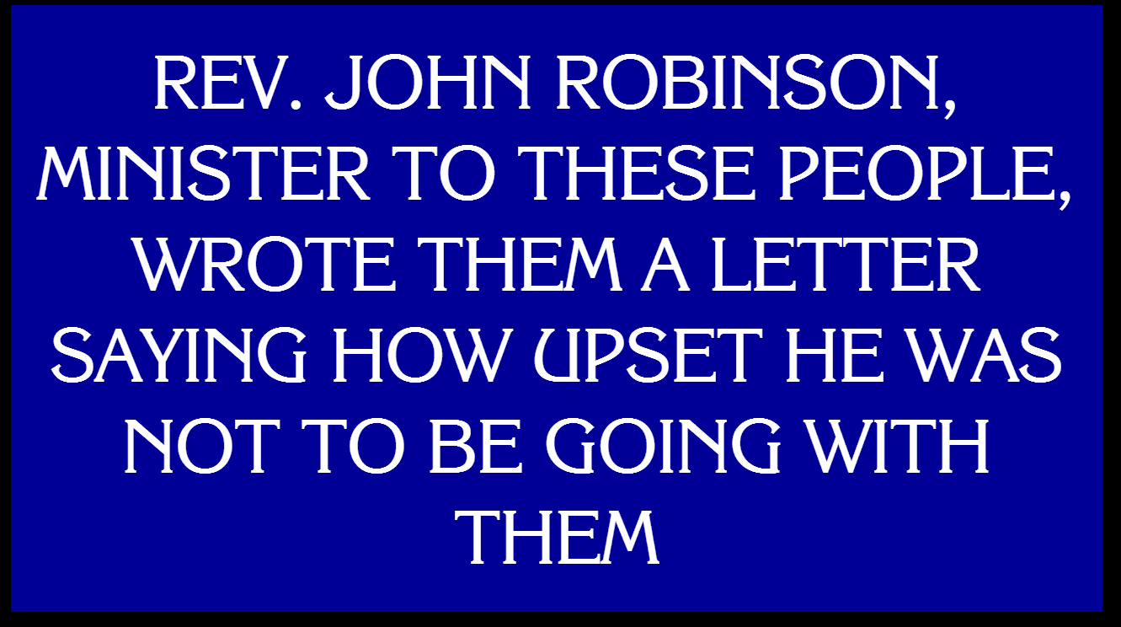

When the 30-second timer is up, the screen will advance automatically. Players reveal their responses. Adjust the scores manually, and crown your Jeopardy champion!

# Appendix A: General Controls

Here is a quick reference on how to control the game, mostly for the host. Below is a list of game states and their descriptions, as well as the controls during those game situations.

1. Any view
   * K - open host key if it is not already open
2. Lectern view, waiting on player response. Buzzers are active. This is the only game state where buzzers are active and players may buzz in. Player buzzers are the only available inputs here, sends the game to state 3.
3. Lectern view, player has buzzed in.
   * C – player gave a correct response, clue value is added to player’s score. Automatically advances to state 4.
   * X – player gave an incorrect response, clue value is deducted from player’s score. Reverts to state 2, allowing other players to buzz in.

o Note: If a player’s time runs out, other players are immediately eligible to buzz in, but the score is not automatically deducted. If this occurs, you may have to manually adjust the scores at the next opportunity after the clue due to the timing of when buttons are pressed.

1. Board view – view of the board with all remaining categories and clues
   * Click on a clue to select it, advancing to state 5.
2. Clue view – view of the clue value and text. The host reads the clue.
   * Host button – view lecterns and active buzzers. Be sure to finish reading the clue before doing this, so that the players cannot buzz in before the clue is completely read. Reverts to state 2, allowing players to buzz in.
3. Daily Double Screen View – a view of the Daily Double graphic. This screen advances automatically to state 7.
4. Daily Double category view – a view of the Daily Double category
   * Host button – view lecterns to allow player to wager. Goes to state 8.
5. Daily Double clue view – Daily Double clue text. The host reads the clue.
   * Host button – start the timer on the daily double. Default timer is 10 seconds, but can be adjusted in the source code. Goes to state 9.
6. Daily Double clue active – Daily Double clue text. The host has read the clue and started the timer. Automatically goes to state 10 when the timer runs out or when the host button is pressed.
   * Host button – view lecterns to allow for score adjustments. Goes to state 10.
7. Daily Double Result View – pause after Daily Double. Host adjusts scores as necessary.
   * Host button – view board. Goes to state 4.
8. Final Jeopardy Category View 1 – First viewing of Final Jeopardy category.
   * Host button – view lecterns to allow users to write wagers.
9. Final Jeopardy Lectern View – players write wagers. Host waits until players are ready before advancing.
   * Host button – show category and clue, advances to state 13.
10. Final Jeopardy Category View 2 – flashes the category one more time. Automatically advances to state 14.
11. Final Jeopardy Clue View – host reads the final Jeopardy clue
    * Host button – start the 30-second timer, advance to state 15.
12. Final Jeopardy Clue Active – timer is running for Final Jeopardy clue. Automatically advances to state 16.
13. Final Result View – players reveal responses and wagers. Host adjusts final scores.

# Appendix B: places where you need to use the host button

Generally, if it looks like the game is stuck, you probably need to hit the host button. Here is a list of times when the host must press the button to continue.

### After reading a clue, to allow players to buzz

1. After a triple-stumper clue (all players miss or clue times out). Take this opportunity to adjust scores if a mistake was made previously.
2. When the category for a daily double is displayed
3. When the player has wagered for the daily double
4. After reading the daily double clue
   1. After reading the daily double clue, and pressing the button, the game will automatically advance to the lectern view if the timer runs out. If the player answers well before the timer runs out, you may press the host button to advance to the next screen.
5. After adjusting the scores following a daily double
6. After viewing the Final Jeopardy category
7. After players are finished wagering for Final Jeopardy
8. After reading the Final Jeopardy clue